Static NAT:

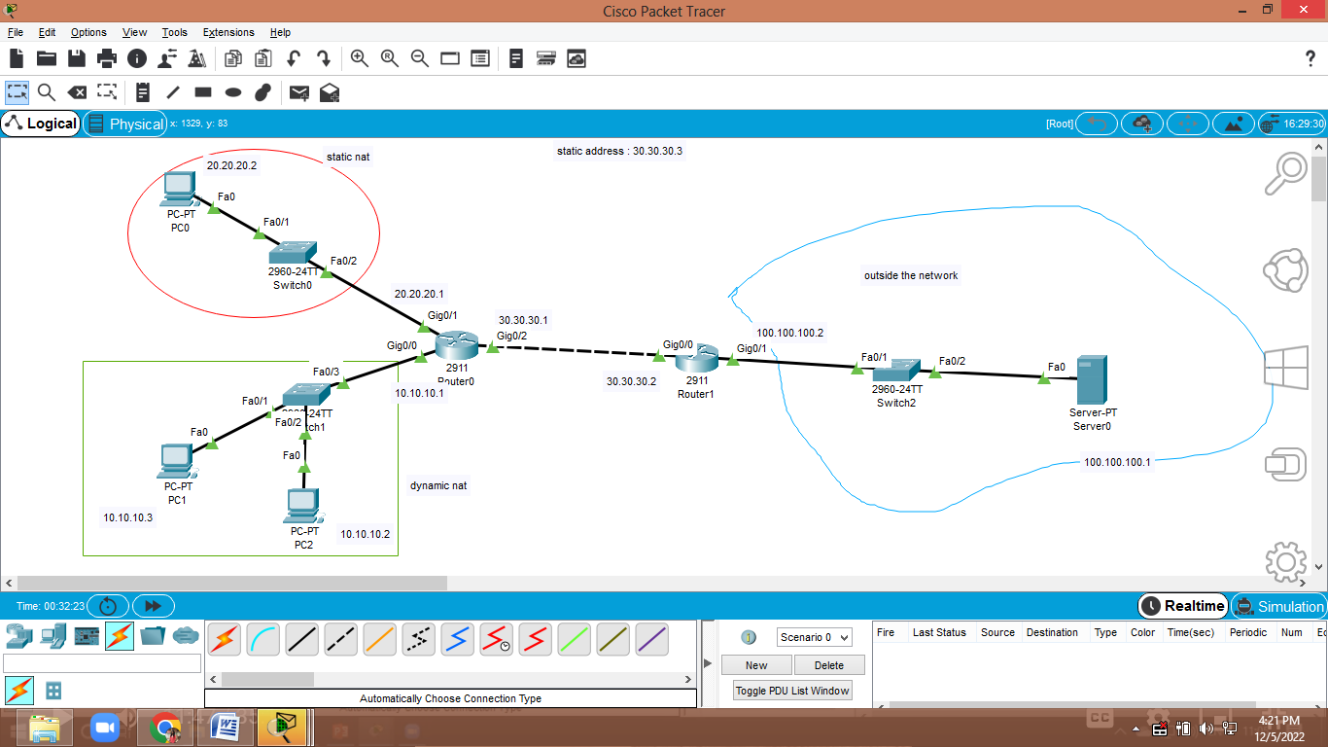

Router#en

Router#config t

Enter configuration commands, one per line. End with CNTL/Z.

Router(config)#int gig0/1

Router(config-if)#ip nat inside

Router(config-if)#exit

Router(config)#int gig0/2

Router(config-if)#ip nat outside

Router(config-if)#exit

Router(config)#ip nat inside source static 20.20.20.2 30.30.30.3

Router(config)#exit

RIP

INSPECT TOOL

Router#show ip nat translation

Pro Inside global Inside local Outside local Outside global

--- 30.30.30.3 20.20.20.2 --- ---

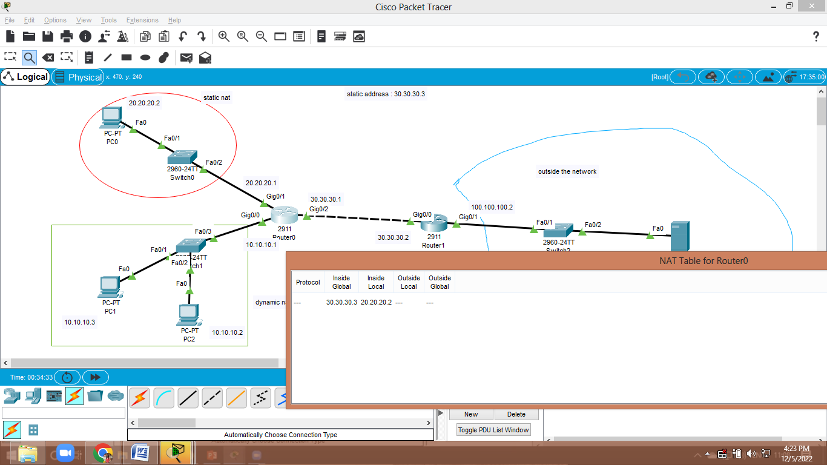

DYNAMIC NAT :

Router#en

Router#config t

Enter configuration commands, one per line. End with CNTL/Z.

Router(config)#int gig0/0

Router(config-if)#

Router(config-if)#ip nat inside

Router(config-if)#int gig0/2

Router(config-if)#ip nat outside

Router(config-if)#exit

Router(config)#

Router(config)# ip nat pool cse 30.30.30.4 30.30.30.7 netmask 255.0.0.0

Router(config)#access-list 10 permit 10.10.10.2 10.10.10.5

Router(config)#ip nat inside source list 10 pool cse